The Book of Revelation (Part 1)

Objective:
- Overview of the book of Revelation
- All the prophecies are hidden and no body knows the exact times.
- The description of Heaven

Memory Verse:
“To him that overcomes I will grant to sit with Me on My throne, as I also overcame and sat down with my Father on His throne” (Revelation 3:21).

References:
- “The book of Revelation,” Fr. Tadros Y. Malati

Introduction:
Many people have misused this book in propagating wild theories. This is a lesson on how we should read this book and what it means to us.

I. Importance of the Book
The Bible starts with Genesis, in which man is cast out of paradise, and ends with Revelation, in which doors are opened in heaven and believers inherit eternal paradise in New Jerusalem.
Revelation is the book in which we find hope, victory, praise, and heaven. We start learning heaven’s language, “praise” on earth.

II. Author, Place and Time
The author is St. John the Evangelist. He was the brother of St. James and also the author of the Gospel of St. John and three epistles named after him.
It was written in a small island named Patmos (Rev 1:9), 25 miles off Asia Minor (Turkey). The majority of scholars believe that it was written in AD 95.

III. The Unique Nature of the Book
Revelation is certainly different from the other books of the New Testament. Unfortunately, this has caused some people to shy away from the book or, on another hand, to misuse it in propagating wild theories.
The word “revelation” (apocalypses in Greek) means an “uncovering” or “unveiling.”

IV. The Difficulty in Understanding the Book
It is a prophetic book; it is the only prophetic book in the New Testament. It prophesizes on spiritual and heavenly facts, that cannot be expressed in human language. That is why it was written in numbers, symbols, and colors.
If we knew the exact times, we would be lazy, and if we were not informed of what was going to happen, as persecutions for example, we could fall in distress. “Blessed is he who reads and those who hear the words of this prophecy, and keep those things which are written in it; for the time is near” (Revelation 1:3).

V. Key Verse
“These will make war with the Lamb, and the Lamb will overcome them, for He is Lord of lords and King of kings; and those who are with Him are called, chosen, and faithful” (Revelation 17:14).

Lesson Outline:

I. Vision of Christ among the Lampstands (Revelation 1:9-20)
- Clothed with a garment down to the foot
- His head and His hair were white like wool, as white as snow.
- His eyes were as a flame of fire.
- His feet like fine brass, as if they were burned in a furnace.
- His voice as the sound of many waters.
- He had in His right hand seven stars.
- Out of His mouth went a sharp two-edged sword, and His countenance was as the sun shining in its strength.

II. Letters to the Seven Churches (Revelation 2:1-3:22)
“He that has an ear let him hear what the Spirit says unto the churches.”

A. The church at Ephesus (Revelation 2:1-7)
- I know your works, your labor, and your patience.
- Nevertheless I have this against you, that you have left your first love.

B. The church at Smyrna (Revelation 2:8-11)
- I know your works, tribulation, and poverty, but you are rich.
- The devil shall cast some of you into prison.
- Be faithful unto death, and I will give you the crown of life.

C. The church at Pergamos (Revelation 2:12-17)
- I know your works and where you dwell, even where Satan’s seat is; and you hold fast to My name.
- But I have a few things against you because you have there those who hold the doctrine of Balaam, who taught Balak to cast a stumbling block before the children of Israel, to eat things sacrificed unto idols, and to commit fornication.

D. The church at Thyatira (Revelation 2:18-29)
- I know your works, charity, service, faith, and patience.
- You allow that woman Jezebel, who calls herself a prophetess, to teach and seduce my servants to commit fornication and to eat things sacrificed to idols.

E. The church at Sardis (Revelation 3:1-6)
- I have not found your works perfect before God.
- If therefore you shall not watch, I will come on you as a thief, and you shall not know what hour I will come upon you.
- You have a few names, even in Sardis, which have not defiled their garments.

F. The church at Philadelphia (Revelation 3:7-13)
- I have set before you an open door.
- Behold, I come quickly; hold fast what you have, that no one may take your crown.

G. The church at Laodicea (Revelation 3:14-22)
- You are neither cold nor hot; I could wish you were cold or hot.
- I will vomit you out of my mouth.
- I stand at the door and knock; if anyone hears My voice and opens the door, I will come to him and I will dine with him and he with Me.
  

The Book of Revelation (Part 2)

Lesson Outline:

I. The throne scene (Revelation 4:1-5:11)
- God on the throne (Revelation 4:1-11)
- Twenty-four priests
- Lightning and thunder out of the throne
- Four Heavenly creatures (All eyes, 6 wings - Lion, calf, man, flying eagle)
- The Lamb prevailed to open the seven-sealed scroll (Revelation 5:1-14).

II. The Opening of the Seven Seals (Revelation 6:1-8:1)

1) First seal: The white horse and its rider (Revelation 6:1-2)
- These are the apostles and preachers of the Bible, victorious over the devil.

2) Second seal: The red horse and its rider (Revelation 6:3-4)
- Wars and prosecution

3) Third seal: The black horse and its rider (Revelation 6:5-6)
- Famine and heresies

4) Fourth seal: The pale (green) horse and its rider (Revelation 6:7-8)
- Death and antichrist

5) Fifth seal: The martyrs under the altar (Revelation 6:9-11)

6) Sixth seal: Cataclysmic disturbances (Revelation 6:12-17) - before antichrist.
- Great earthquake, sun became black, moon became as blood; stars of heaven fell unto the earth, heaven departed as a scroll when it is rolled together; and every mountain and island were moved out of their places
- The kings of the earth, and the great men, and the rich men, and the chief captains, and the mighty men, and every bondman, and every free man, hid themselves in the dens and in the rocks of the mountains and said to the mountains and rocks, “Fall on us, and hide us from the face of Him that sits on the throne, and from the wrath of the Lamb.”

7) Seventh seal: Silence in heaven for half an hour (Revelation 8:1)
- Beginning of rest

III. The Sounding of Seven Trumpets (Revelation 8:2-11:19)
- First trumpet: Hail and fire; the third of the vegetation is destroyed (Rev 8:7); God’s warning to man
- Second trumpet: The third of the sea creatures and ships are destroyed (Rev 8:8-9)
- Third trumpet: A great star fell; the third of the rivers and springs became bitter (Rev 8:10-11)
- Fourth trumpet: The third of the sun, moon, and stars are struck, affecting day and night (Rev 8:12).
- Fifth trumpet (first woe): Locusts from the bottomless pit are sent to torment men (Rev 9:1-12); this is the period before the antichrist.
- Sixth trumpet (second woe): Four angels with an army of two hundred million, killing a third of mankind (Rev 9:13-21)
- Another interlude (Rev 10:1-11:14)
- The angel with the little book (Rev 10:1-11): The pain of the Church in the antichrist period
- The two witnesses (Rev 11:1-13): Elijah and Enoch are killed; their bodies are left in the streets for 3½ days and then resurrected.
- Seventh trumpet (third woe): The victory of Christ, and His kingdom proclaimed (Rev 11:14-19)

IV. The Great Conflict (Revelation 12:1-14:20)
- A woman clothed with the sun, the moon under her feet, and upon her head a crown of twelve stars: the Church
- Red dragon: The antichrist
- And there was war in heaven: Michael and his angels fought against the dragon, and the dragon and his angels fought. And the great dragon was cast out, that old serpent, called the Devil, and Satan, which deceived the whole world; he was cast out into the earth, and his angels were cast out with him.

V. The Seven Bowls of Wrath (Revelation 15:1-16:21)
- “And they sing the song of Moses the servant of God, and the song of the Lamb, saying, ‘Great and marvelous are your works, Lord God Almighty; just and true are your ways, your King of saints.’”
- God does this out of love to allow people to repent.

VI. The Fall of Babylon, the Harlot (Revelation 17:1-19:10)
- The fall of Babylon the Great proclaimed and mourned (Revelation 18:1-24): The Devil is defeated
- The exaltation in heaven over the fall of the great harlot (Revelation 19:1-5)

VII. The New Jerusalem Described
- God with His people (Revelation 21:1-8)
- The New Jerusalem

VIII. Conclusion (Revelation 22:6-21)
- The time is near; do not seal up the book (Revelation 22:6-11).
- The testimony of Jesus, the Spirit, and the Bride (Revelation 22:12-17)
- Warning not to tamper with the book, and the closing prayers (Revelation 22:18-21)
There are many things in the book of Revelation that are not completely understood yet. However, the day of anyone’s death is actually the end of life, which could come at any minute and any time. Therefore, we should always be ready for the end of our life and the second coming of the Lord.

Applications:
- Search for the similarities between the book of Daniel and the book of Revelation.
- Read an explanation to the book of Revelation written by one of the fathers of the Church.
  

Introduction to the Book of Revelation
THE SIGNIFICANCE OF THE BOOK
The Holy Bible began with the Book of Genesis that proclaimed the endless love of God towards man. He created everything for him, bestowed authority upon him and granted him much dignity. Yet the scene soon changed and the picture was distorted. Man appeared leaving Paradise, expelled, degraded and bearing upon his shoulders the bitter crime of mutiny. He was afraid to meet with God and escaped from divine justice.
But thanks to God who did not leave man to live in this condition, which was brought by sin. He concluded His Bible with the Book of Revelation, giving us a joyous picture: an open gate in heaven, an eternal Paradise awaiting humanity, a divine bosom hastening towards mankind, heavenly harps, joy and a heavenly wedding.
What a delightful and splendid book that is appropriate for every believer to hold, keep at heart, meditate on, and constantly repeat day and night. It is the book of hope, victory and praise; entirely, it is the book of heaven.
1. THE BOOK OF HOPE
Whoever reads the Book of Revelation discovers what Christian worship actually is. It is not just duties to be carried out, rituals to be performed or orders to be observed, but one sees the invisible, divine hands hurrying towards him to receive him, embrace him and raise him up to heavens where he lives as a partner in eternal glory.
Whoever tastes the Book of Revelation, no matter how many his fasts are, how long his prayers are, his kneeling, asceticism, depravation, suffering and his everyday crucifixion, finds out that they all turn to unspeakable joy and happiness. Through this book, one is dazzled by the love that binds the Creator with His creation, the victorious with the strugglers and the heavenly with the human. Thus one forgets about every pain and hardship for the sake of this everlasting love.
2. THE BOOK OF VICTORY
When the soul enters the Book of Revelation as a bride visiting her Bridegroom's heaven, she sees a wonderful Paradise and a startling glory prepared to receive her.
There she becomes a friend of the Bridegroom. She accompanies His servants, and she falls in love in a heavenly atmosphere of joy and sweetness. At that time, she will not fear the slyness of her enemy, "Satan," or get disturbed by him because she will recognize the power of her Bridegroom, His plans, disposals and intentions towards her.
3. THE BOOK OF PRAISE
When the believer spends some time secretly, escaping from the outer and inner voices and entering calmness and silence with the Bridegroom in the book, there he hears hymns of praise and learns the language of unceasing praise.
It is beautiful that the believer does not listen to unknown hymns, but feels that he had learnt it before at his mother's house, “the Church,” when he listened to the "hymn of Moses," the "Lamb's hymn" and the hymn of the "Sanctification.” On these and others, the church trains every heart unceasingly, as we shall see.
4. THE BOOK OF HEAVEN
When the believer forgets all that's around him, withdraws from among earthly treasures and enters into the Book of Revelation, he gets dazzled by the treasures he sees. He will see heavenly glories which words cannot describe. He will see precious stones, crowns and white robes. Therefore his heart settles there and refuses to belittle itself again by getting involved in earthly distractions. One will sell all his pearls to acquire the one pearl of great price.
THE WRITER OF THE BOOK
The early Church unanimously agreed that the writer of the book is St. John the Evangelist. This was proven by the following:
- The writings of the early Church attribute the book to him.
- He was the apostle, considered by the churches of Asia Minor, who was mentioned in the book.
- History assures us that John the Beloved was exiled by the Emperor Domitian to Patmos Island, where the apostle beheld his revelation (1:9).
- Although the theme of his book differs from the Gospel according to St. John, some typical words occurred in both books but not in others, like "the Word, the Lamb, the Victory..." and also the word “truth” was repeated in both books.
- The apostle did not hide his name, but mentioned it frankly four times in this book. This is because he is talking about prophecies. In order to trust them, we need to know the writer whom God had inspired. Yet, he did not mention his name in his Gospel or in the three epistles, out of humbleness.
PLACE OF WRITING OF THE BOOK
The apostle wrote this book during his exile (1:9) in a small and rocky island that lies about 25 miles far from the shores of Asia Minor (modern Turkey); it was called Patmos and is now called “Patino.” It is about 10 miles long and 6 miles wide.
Some scholars think that he recorded the revelation he saw during his exile when he returned to Ephesus. There is no proof to support this opinion, especially since he was ordered to write what he saw without delay (1:10 & 11).
On this island there is a cave which the inhabitants call the apostle's residence during his exile.
TIME OF WRITING THE BOOK
The majority believe that it was written after the destruction of Jerusalem, at about the year 95 A.D. St. Irenaeus says that this revelation was proclaimed at the end of Domitian’s reign.
THE CONCERN OF THE CHURCH WITH THE BOOK
In spite of what heretics like Marcion stirred up with regards of the canonity of this book, we find that the Church gave it special care since the early centuries. Therefore some fathers explained it and some wrote articles about it, among them are Justin the Martyr, Irenaeus, Hippolytus, Melito, Victorinus, Dionysius of Alexandria, Methodios, Basil the Great, Gregory of Naznianzus, Cyril the Great and Gennadius.
THE DIFFICULTY OF THE BOOK
The interpretation of the Book of Revelation is considered a difficult task for the following reasons:
      - It’s a prophetic book (22:7). It is the only prophetic book in the New Testament.
      - It prophesies about spiritual, heavenly facts that cannot be expressed by human languages; therefore it came in numbers, symbols, colors and similes.
      - It talks about secrets whose details the faithful does not need to understand because if he knows about the times, he will get lazy and hopeless. And if he does not know about the hardships he might face during his struggle, he will fall victim to despair.
      - The Book of Revelation therefore presents to us enough events to make the heart burn with fervor and get filled with hope, without being concerned with times or being curious about future events.
      - Its words bear profound meanings before which the Church fathers stood in amazement.
St. Jerome wrote to Fr. Paulinus, Bishop of Nola, saying, “The secrets of the Book of Revelation are as numerous as its words, each word bears a secret. Still, this is little compared to the high honor of this book; in fact, every praise is significant because every word carries many meanings. In this book, I praise what I understand and what I do not understand.”
Pope Dionysius of Alexandria says, “...having formed an idea of it as a composition exceeding my capacity of understanding, I regard it as containing a kind of hidden and wonderful intelligence on the several subjects which come under it. For though I cannot comprehend it, I still suspect that there is some deeper sense underlying the words. And I do not measure or judge its expressions by the standard of my own reason, but, making more allowance for faith, I have simply regarded them too lofty for my comprehension; and I do not forthwith reject what I have not been able to discern of important.”
THE KEY TO THE BOOK
In this book the Holy Spirit accompanies the human soul on the eternal road, revealing to its inner senses how to see, hear, touch and grow stronger until it reaches the eternal wedding.
- It begins by showing an "open door in heaven” to ascend to, through our Lord Jesus, the Lamb standing as if slain ... and what do we see?
- We see first "the state of the Seven Churches," that reveals the extent of the human weakness and how powerful the work of grace is in the Church. Here our Lord Jesus comes to announce that He is the only cure for our weaknesses.
- Then He carries the human soul up, as if on dove’s wings, towards eternity on the road of the cross, the road of pain, to see the Lamb opening "the Seven Seals," proclaiming a state of permanent war between God, who cares for His children, and Satan, who never ceases fighting against the children of God.
- And we hear "the Seven Trumpets," proclaiming God's warnings to mankind in order not to accept Satan’s deception but to be attached to God. They also proclaim the power of the woman clothed with the Sun against her enemy, the sea monster and whoever he arouses ("the sea beast and the land beast”).
- And you see the "Seven Stokes" to discipline the wrongdoers so that they might repent, revealing the destruction befalling the adulteress and her lovers.
- Every time the soul discovers a bitterness which pervades mankind or a difficulty that encompasses the faithful, we find that the Person of our Lord Jesus immediately appears in one way or another to encourage, sympathize and strengthen His children in order to accomplish their struggle in peace.
- At last, the Spirit accompanies the soul into “Heavenly Jerusalem” to see and get dazzled by what is set for her and what God has planned for mankind; as she watches with her eyes, Satan, the enemy of humanity, is thrown down into the lake burning with fire.
SECTIONS OF THE BOOK
- The Seven Churches (Chapters 1 – 3).
- The Prophetic Revelations (Chapters 4 – 20).
- The Glory of Heavenly Jerusalem (Chapters 21 – 22).
Important Notice
Many people have distorted the Book of Revelation by changing its interpretation into a search for details of future events and matters that we do not have to investigate, unaware of the noble spiritual meanings that God wants to proclaim in order for us to live by them and grow spiritually. We are not required to set up prophets of ourselves in order to see and proclaim what is irrelevant to man's life and salvation, so we might not hear that reproach which previously followed the request: "Show the things that are to come hereafter, that we may know that You are God" (Isaiah 41: 22, 23).
  

The Book of Revelation
(Abbreviated Story for Kids)
- The Revelation of St. John
  - All the Apostles died except St. John.
    - The Roman Emperor arrested him and sent him into exile to a deserted island, called Patmos. Why?
    - The Lord appeared to him and revealed what would happen to the Church and the world in the future.
  - The Lord showed him the Holy City, New Jerusalem.
    - It had a great wall with 12 gates made out of precious stones; an angel stood at each gate.
    - Its wall was made of jasper.
    - The City was pure gold, like clear glass.
    - The foundations of the wall were made out of 12 precious stones.
    - The 12 gates were each made out of 1 pearl.
  - There was no night in the City.
    - No need for sun or moon; the Glory of God shines in it.
    - The Lord God Almighty and the Lamb is its Temple.
    - Its gates are never shut.
  - Who can enter this City?
    - Nothing that defiles
    - Nothing that causes abomination
    - No liar
    - Only those written in the Lamb’s Book of Life
- Conclusion:
Do you want to go to New Jerusalem? Lead a good Christian life to show that you are really waiting for the second coming of our Lord and for New Jerusalem.
  

Revelation Chapters 21 & 22

“Now I saw a new heaven and a new earth, for the first heaven and the first earth had passed away.” The Apostle St. Peter assured us that by the coming of our Lord, “The heavens will be dissolved being on fire, and the elements will melt with fervent heat! Nevertheless, we, according to His promise look for new heavens and a new earth in which righteousness dwells.” (2 Peter 3:12, 13)

“Also there was no sea.” The sea indicates division and separation; it separates cities, countries, and continents. But in heaven nothing will separate the members of the Church from each other. The sea also refers to confusion and worry, as the Bible says, “But the wicked are like the troubled sea, when it cannot rest, whose water cast up mire and dirt.” (Is. 57:20)

By the descent of New Jerusalem, St. Augustine declares that we have to experience heavenly life while we are still on earth, before the coming of the day of the Lord.

The Bible describes New Jerusalem as “having the glory of God. And her light was like a most precious tone, like a jasper stone, clear as crystal.” Her glory is not out of her, but it is God’s glory shining over her. Like crystal, she receives the heavenly glories; likewise, by uniting with Him and accepting the brilliance of His glory, we become like jasper stone, clear as crystal. Every one of us as a stone of crystal shall see the glory of God in his brother, and his brother shall see the glory of God in him; thus the glory of God shall be all in all.

The 12 gates had the names of the twelve tribes of the children of Israel written on them. There were 3 gates on the east, 3 gates on the north, 3 gates on the south, and 3 gates on the west. “Now the wall of the city had twelve foundations, and on them were the names of the twelve apostles of the Lamb.” She brought together the names of the twelve tribes, or men of the Old Testament, with the names of the apostles of Christ, who are the men of the New Testament; it is one Church. The gates are distributed in all directions so that every one who desires the eternal inheritance can reach her.

“And he who talked with me had a gold reed to measure the city, its gates, and its walls.” The gold reed is a heavenly unit of measurement because spiritual and heavenly matters are only measured by what is spiritual and heavenly. It measures 12,000 furlongs because the number 12 indicates God’s children and the number 1,000 indicates heaven; therefore, it embraces all of God’s children. “Then he measured its wall: 144 cubits, according to the measure of a man, that is, of an angel.” The number 144 refers to the universal Church (The Church of the Old Testament [12] x the Church of the New Testament [12]).

“The foundations of the wall of the city were adorned with all kinds of precious stones.” These precious stones are indicative of the Apostles of Christ, as it is an Apostolic Church. The Bible says, “Having been built on the foundation of the apostles and prophets, Jesus Christ Himself being the Chief Cornerstone.” (Eph. 2:20) The precious stones also indicate the divine virtues that God bestows on us to adorn us.

“And the twelve gates were twelve pearls; each individual gate was of one pearl.” The Lord Jesus is the pearl of great value for which man sells all that he has to acquire. (Matt 13:46) The sons of the kingdom, entering its gates, have all sold the world and bought the pearl.

“And the street of the city was pure gold, like transparent glass.” The whole city is of pure gold, or heavenly without anything earthly. And it’s like transparent glass, with no defilement or complication but only simplicity and purity of heart.

“But I saw no temple in it, for the Lord God Almighty and the Lamb are its temple.” The temple always bears the meaning of God dwelling among His people. When the Jews deviated and refused the Lord, the temple was destroyed. Then the Lord offered to us His Body as a New Temple. (John 2:19)

“And the city had no need for the sun or of the moon to shine in it, for the glory of God has illuminated it, and the Lamb is its light.” The material means of lighting have disappeared because the Lord became the Sun and the Lamp for us.

“And the nations of those who are saved shall walk in its light, and the kings of the earth bring their glory and honor into it. Its gates shall not be shut at all by day (there shall be no night there). And they shall bring the glory and the honor of the nations into it. But there shall by no means enter it anything that defiles, or causes an abomination or a lie, but only those who are written in the Lamb's Book of Life.” The Lord says, “And I say to you that many will come from east and west, and sit down with Abraham, Isaac and Jacob in the kingdom of heaven.” (Matt 8:11) It receives all people without partiality for the rich or the poor, the slave or the free. God desires all men to be saved and to come to the knowledge of the truth.

“And he showed me a pure river of water of life, clear as crystal, proceeding from the throne of God and of the Lamb. In the middle of its street, and on either side of the river, was the tree of life, which bore twelve fruits, each tree yielding its fruit every month. The leaves of the tree were for the healing of the nations.”
Tertullian says that we cannot explain this text literally, for in the eternal life there are no rivers or streets or trees. The Apostle says that the tree of life stands in the middle of the street of the city, and in the same time the tree itself stands on the shore of the river from both sides. How then can this be if it’s literally explained?!

The River of Life:

Tertullian is of the opinion that the river is the Person of our Lord Jesus who gives water to every soul. He is the Lamb who saved us and the Tree of Life who feeds His children.

St. Ambrose believes that the river is the Holy Spirit; “He who believes in Me, as the Scripture has said, out of his heart will flow rivers of living water … But this He spoke concerning the Spirit whom those believing in Him would receive.” (John 7:37-39)

It also refers to the delightful flow of God’s blessings in eternity; as the Psalmist says, “There is a river whose stream shall make glad the city of God, the holy place of the tabernacle of the Most High. God is in the midst of her, she shall not be moved.” (Ps. 46:4, 5)

It also indicates the eternal peace, as it says, “Behold I will extend peace to her like a river … and your shall be comforted in Jerusalem. When you see this, your heart shall rejoice.” (Is. 66:12-14)

The Tree of Life:

Thycon the African thinks that the tree of life indicates the Holy Cross to which we extend our hands to pick all kinds of pleasant fruits.

St. Ephrem the Syrian and others call the Cross the tree of life because with the Cross our Lord had conquered death and opened heaven to us.

Its fruits are 12 in number, indicating that every one of the children of the kingdom finds his needs and satisfaction.

“And there shall be no more curse.” Our father Adam was expelled from Paradise and went out moaning because of the heavy curse he was carrying on his shoulders, as a result of his disobedience. But in eternity, sin and disobedience do not exist; all people will serve God in perfect obedience. “They shall see His face, and His name shall be on their foreheads.”

“There shall be no night there: They need no lamp nor light of the sun, for the Lord God gives them light. And they shall reign forever and ever.” It is the presence of God, “Sun of Righteousness,” that surrounds and shelters them. St. Augustine says, “What is the light but You my God! You are the Light to the children of light! Your days do not have a sunset! Your day gives light to Your children that they might not stumble down. But those who are away from You walk and live in darkness! Let us then get close to You who are the Light of the world. Anyone who keeps distant from you, the True Light, goes deeper into the darkness of sin.”

“Behold I am coming quickly.” He warns us not to waste time in doubting. “Behold the Bridegroom is coming in the middle of the night. Blessed is the servant whom He finds awake. But that servant whom He finds negligent is not worthy to walk with Him. Be watchful then my soul, lest you should fall asleep and be found outside the kingdom. Keep awake in supplication and prayer that you may meet the Lord Christ with fat oil and that He may grant you the true glorious divine wedding.” (The 1st Watch of the Midnight Prayer)
  

Illustrations for the Book of Revelation

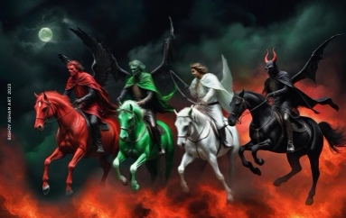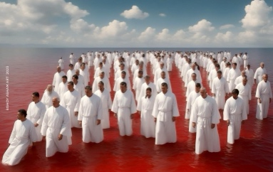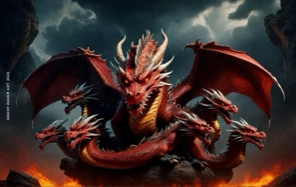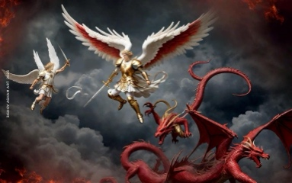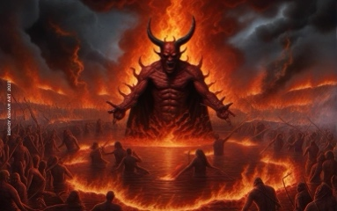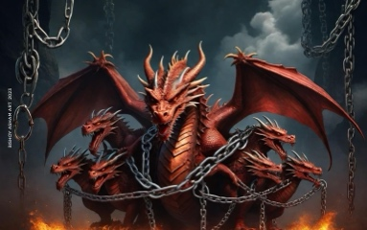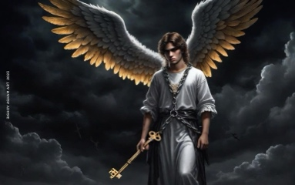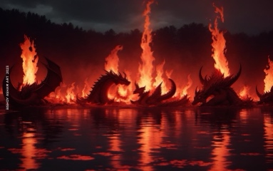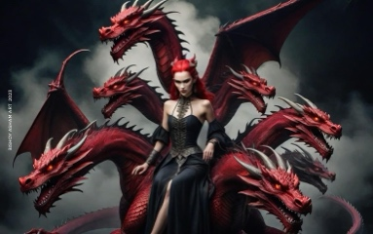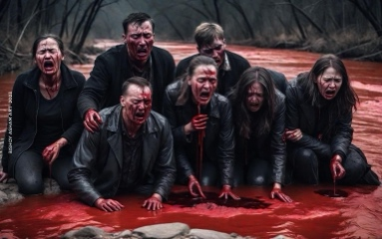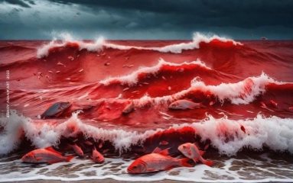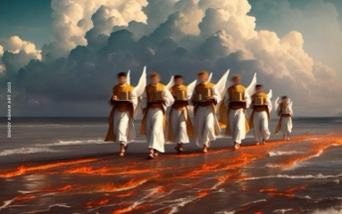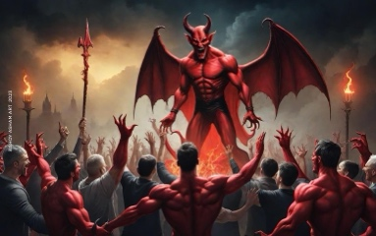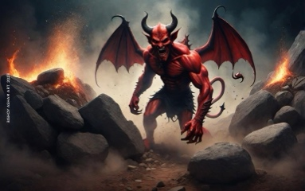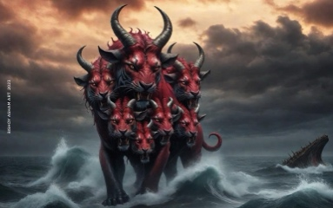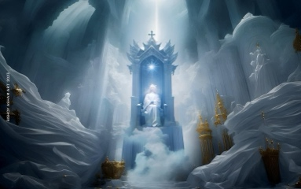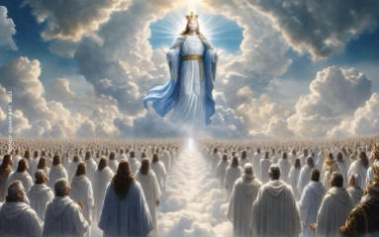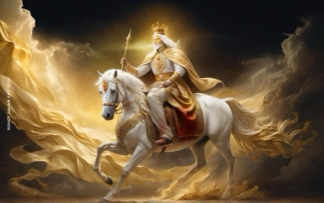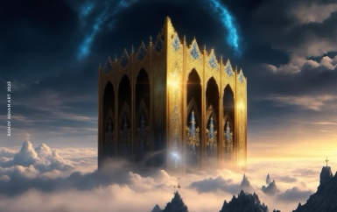
  

NAME: ____________________________
first last .

The Book of Revelation
Verse to Memorize:
To him that overcomes I will grant to sit with Me on My throne, as I also overcame and sat down with my Father on His throne.
Revelation 3:21
1. Where was St. John when he saw this vision?
a) Jerusalem b) Rome c) Egypt d) Patmos e) Antioch
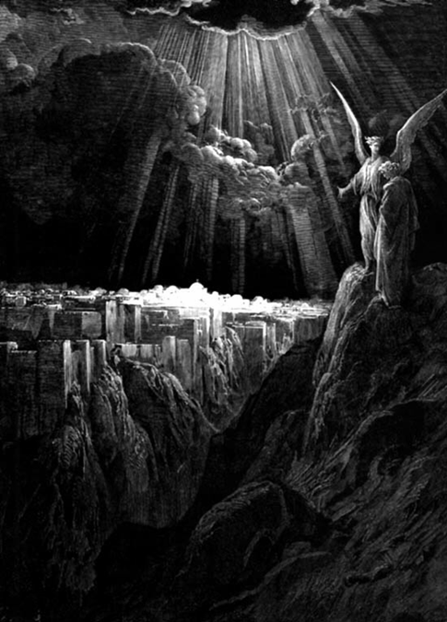
- In approximate what year was this book written? _________
- What is the Greek word for “revelation”? _______________
- Name the 7 churches the letter in chapter 2 was addressed to:

  - _________________
  - _________________
  - _________________
  - _________________
  - _________________
  - _________________
  - _________________

- “These will make __________ with the Lamb, and the __________ will overcome them, for He is ___________ of Lords and ___________ of kings; and those who are with Him are called chosen and _____________. (Rev 17)
- Why doesn’t the book give us the exact time when the world will end?

- Nothing will enter New Jerusalem that ____________

  - defiles
  - causes hate
  - brings a lie
  - causes a curse

  - all the above

 The Book of Revelation, by Fr. Tadros Y. Malaty, translated by Victoria and Ramzy Malaty, St. George Coptic Orthodox Church, Sporting-Alexandria, 1996
 Prepared by Ossama Ekladious, St. George Coptic Orthodox Church, Bellflower, CA
❖ References Used: The Book of Revelation (Commentary), Fr. Tadros Yacoub Malaty, translated by Victoria & Ramzy Malaty, St. George Coptic Orthodox Church, Sporting- Alexandria, Egypt, 1998

