The Revelation of John and the Heavenly Jerusalem

Objective
- Love the Kingdom of Heaven and follow the example of the Saints.

Memory Verse
“Praise the Lord! Praise God in His Sanctuary” (Psalm 150:1)

References
- Revelation 2l

Introduction
Use beautiful pictures to show the beauty of heaven. Artistic conditions should be observed so that a wrong picture may not be printed in the mind of a child about heaven. Angels’ wings, candles, palm leaves.

- What is the name of the first martyr in Christianity?
- What did he request the Lord to do for those who stoned him?
- When did the Lord’s disciples begin their evangelism in the world?
- Who evangelized in Egypt?

Lesson Outlines
A glimpse about some of the disciples and apostles of the Lord Jesus:
St. Peter the apostle was one of Christ’s disciples. He evangelized about the Lord Christ openly in public and his shadow healed the sick. St. Paul the apostle is not one of the twelve disciples. The Lord chose him to preach His name before pagan kings and kingdoms at that time. Many people accepted the faith and believed through him. He established many churches in the world. Sts. Paul and Peter were martyred in Rome. The Emperor sentenced them to death. St. Peter requested that he be crucified with his head down, and he was crucified in the manner he desired; but St. Paul was beheaded with the sword. They attained the crown of glory and went to the bosom of the saints.

- How was St. Peter the apostle martyred? And St. Paul?
- Where are they now?
- Let us sing a hymn: “Sts. Peter and Paul the two apostles…”

Years went by and all the apostles died except St. John. The Roman Emperor arrested him and ordered that St. John should spend the rest of his life alone in Patmos, far away from his friends and acquaintances. The Lord did not leave St. John alone; He appeared to him and revealed to him what was about to happen to the Church and the world in the future. Inspired by the Holy Spirit, St. John wrote all that he saw in a book called Revelation. It is the last Book in the Holy Bible. The Lord showed him the Holy City, New Jerusalem. He saw a beautifully colored door and two angels were guarding that door. The ground of Paradise was green and covered with bright colors. He saw the angels dressed in white and the sky was shining. He saw the place where Christ dwells and two rows of angels bowing in worship and shouting with praise saying, “Holy, Holy...etc. He saw a very big chair of gold on which Christ sat and very bright light surrounded him. Twenty-four priests surrounded Him. He saw four living creatures giving glory to the Lord as well as many people rejoicing and glorifying God. All the people bowed and worshipped the Lord saying, “Holy, Holy, Holy…” Angels flew around the Lord singing sweet songs and saying, “The Cherubim worship You …” St. John longed to enjoy what he saw. He longed to see the Lord coming again; he said, “Come, O Lord Jesus.” St. John heard the Lord say, “I’ll come soon,” and St. John said, “Amen, Come O Lord Jesus.” As for you, are you longing for His second coming? Lead a good Christian life to show that you are really waiting for the second coming of our Lord from heaven.

- Where was St. John when he saw this vision?
- Who sent him into exile?
- Why? What do you say to a man who asks you about your religion?
- Let us repeat together: “Praise the Lord …”
- Who can say the verse?

Conclusion
- St. Paul the Apostle could not describe heaven. All he said was: “What no eye has seen, nor ear hear, nor the heart of man conceived, what God has prepared for those who love him”.

Applications
Answer the following questions:
- How was each of Sts. Peter, Paul and Stephen martyred?
- Describe the angels as seen by Beloved St. John.
  

The Holy Bible
Revelation 21
1 | Now I saw a new heaven and a new earth, for the first heaven and the first earth had passed away. Also there was no more sea.
2 | Then I, John, saw the holy city, New Jerusalem, coming down out of heaven from God, prepared as a bride adorned for her husband.
3 | And I heard a loud voice from heaven saying, "Behold, the tabernacle of God is with men, and He will dwell with them, and they shall be His people. God Himself will be with them and be their God.
4 | "And God will wipe away every tear from their eyes; there shall be no more death, nor sorrow, nor crying. There shall be no more pain, for the former things have passed away."
5 | Then He who sat on the throne said, "Behold, I make all things new." And He said to me, "Write, for these words are true and faithful."
6 | And He said to me, "It is done! I am the Alpha and the Omega, the Beginning and the End. I will give of the fountain of the water of life freely to him who thirsts.
7 | "He who overcomes shall inherit all things, and I will be his God and he shall be My son.
8 | "But the cowardly, unbelieving, abominable, murderers, sexually immoral, sorcerers, idolaters, and all liars shall have their part in the lake which burns with fire and brimstone, which is the second death."
9 | Then one of the seven angels who had the seven bowls filled with the seven last plagues came to me and talked with me, saying, "Come, I will show you the bride, the Lamb's wife."
10 | And he carried me away in the Spirit to a great and high mountain, and showed me the great city, the holy Jerusalem, descending out of heaven from God,
11 | having the glory of God. Her light was like a most precious stone, like a jasper stone, clear as crystal.
12 | Also she had a great and high wall with twelve gates, and twelve angels at the gates, and names written on them, which are the names of the twelve tribes of the children of Israel:
13 | three gates on the east, three gates on the north, three gates on the south, and three gates on the west.
14 | Now the wall of the city had twelve foundations, and on them were the names of the twelve apostles of the Lamb.
15 | And he who talked with me had a gold reed to measure the city, its gates, and its wall.
16 | The city is laid out as a square; its length is as great as its breadth. And he measured the city with the reed: twelve thousand furlongs. Its length, breadth, and height are equal.
17 | Then he measured its wall: one hundred and forty-four cubits, according to the measure of a man, that is, of an angel.
18 | The construction of its wall was of jasper; and the city was pure gold, like clear glass.
19 | The foundations of the wall of the city were adorned with all kinds of precious stones: the first foundation was jasper, the second sapphire, the third chalcedony, the fourth emerald,
20 | the fifth sardonyx, the sixth sardius, the seventh chrysolite, the eighth beryl, the ninth topaz, the tenth chrysoprase, the eleventh jacinth, and the twelfth amethyst.
21 | The twelve gates were twelve pearls: each individual gate was of one pearl. And the street of the city was pure gold, like transparent glass.
22 | But I saw no temple in it, for the Lord God Almighty and the Lamb are its temple.
23 | The city had no need of the sun or of the moon to shine in it, for the glory of God illuminated it. The Lamb is its light.
24 | And the nations of those who are saved shall walk in its light, and the kings of the earth bring their glory and honor into it.
25 | Its gates shall not be shut at all by day (there shall be no night there).
26 | And they shall bring the glory and the honor of the nations into it.
27 | But there shall by no means enter it anything that defiles, or causes an abomination or a lie, but only those who are written in the Lamb's Book of Life.
Revelation 22:1-7
1 | And he showed me a pure river of water of life, clear as crystal, proceeding from the throne of God and of the Lamb.
2 | In the middle of its street, and on either side of the river, was the tree of life, which bore twelve fruits, each tree yielding its fruit every month. The leaves of the tree were for the healing of the nations.
3 | And there shall be no more curse, but the throne of God and of the Lamb shall be in it, and His servants shall serve Him.
4 | They shall see His face, and His name shall be on their foreheads.
5 | There shall be no night there: They need no lamp nor light of the sun, for the Lord God gives them light. And they shall reign forever and ever.
6 | Then he said to me, "These words are faithful and true." And the Lord God of the holy prophets sent His angel to show His servants the things which must shortly take place.
7 | "Behold, I am coming quickly! Blessed is he who keeps the words of the prophecy of this book."
  

Illustrations for the Book of Revelation

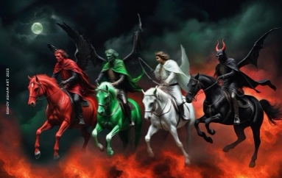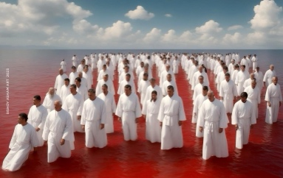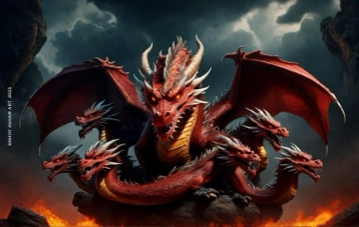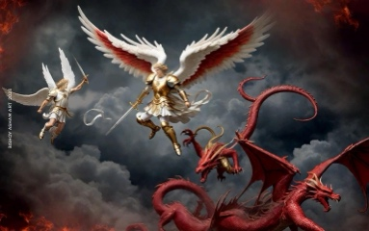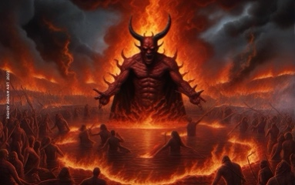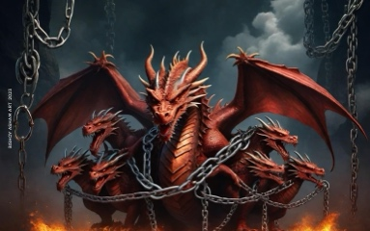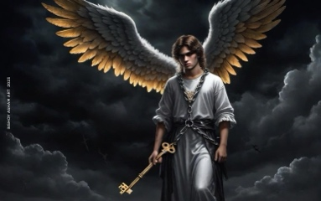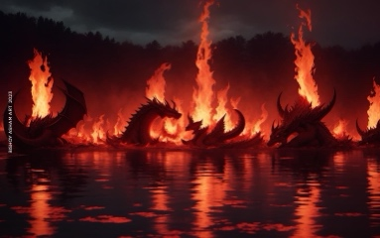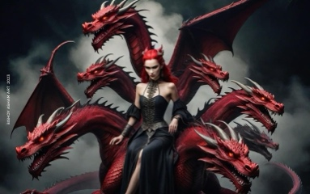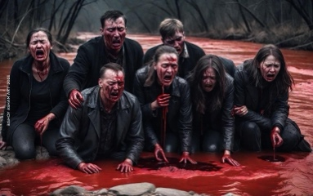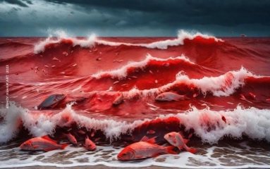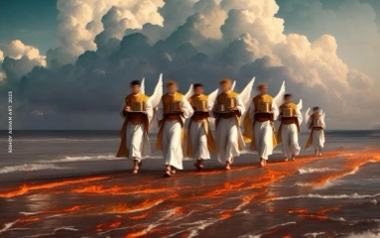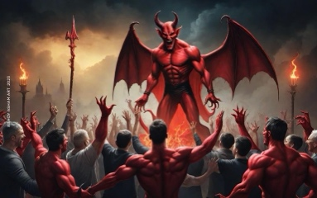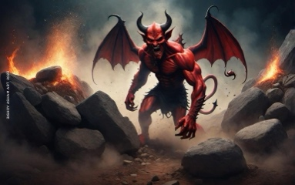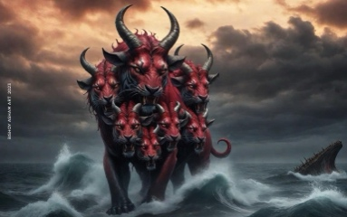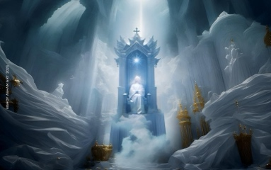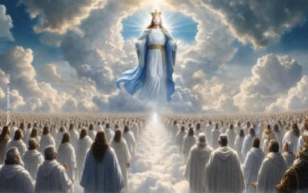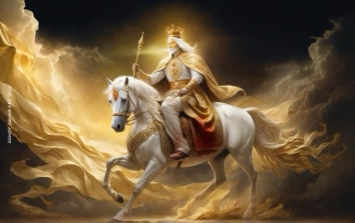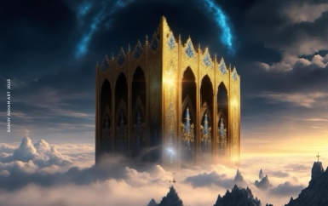
  

The Revelation of John and the Heavenly Jerusalem
(Abbreviated Story for Kids)
- Feast of the Apostles (Introductory Questions)
  - Who was the 1st martyr in Church? What did he request the Lord to do for those who stoned him?
  - When did the Lord’s disciples begin to evangelize? Who evangelized Egypt?
  - How was St. Peter the Apostle martyred? And St. Paul? Where are they now?
- The Revelation of St. John
  - All the Apostles died except St. John.
    - The Roman Emperor arrested him and sent him into exile to a deserted island, called Patmos. Why?
    - The Lord appeared to him and revealed what would happen to the Church and the world in the future.
  - The Lord showed him the Holy City, New Jerusalem.
    - It had a great wall with 12 gates made out of precious stones; an angel stood at each gate.
    - Its wall was made of jasper.
    - The City was pure gold, like clear glass.
    - The foundations of the wall were made out of 12 precious stones.
    - The 12 gates were each made out of 1 pearl.
  - There was no night in the City.
    - No need for sun or moon; the Glory of God shines in it.
    - The Lord God Almighty and the Lamb is its Temple.
    - Its gates are never shut.
  - Who can enter this City?
    - Nothing that defiles
    - Nothing that causes abomination
    - No liar
    - Only those written in the Lamb’s Book of Life
- Conclusion:
Do you want to go to New Jerusalem? Lead a good Christian life to show that you are really waiting for the second coming of our Lord and for New Jerusalem.
  

Supplemental Notes for

The Revelation of John and the Heavenly Jerusalem

“Now I saw a new heaven and a new earth, for the first heaven and the first earth had passed away.” The Apostle St. Peter assured us that by the coming of our Lord, “The heavens will be dissolved being on fire, and the elements will melt with fervent heat! Nevertheless, we, according to His promise look for new heavens and a new earth in which righteousness dwells.” (2 Peter 3:12, 13)

“Also there was no sea.” The sea indicates division and separation; it separates cities, countries, and continents. But in heaven nothing will separate the members of the Church from each other. The sea also refers to confusion and worry, as the Bible says, “But the wicked are like the troubled sea, when it cannot rest, whose water cast up mire and dirt.” (Is. 57:20)

By the descent of New Jerusalem, St. Augustine declares that we have to experience heavenly life while we are still on earth, before the coming of the day of the Lord.

The Bible describes New Jerusalem as “having the glory of God. And her light was like a most precious tone, like a jasper stone, clear as crystal.” Her glory is not out of her, but it is God’s glory shining over her. Like crystal, she receives the heavenly glories; likewise, by uniting with Him and accepting the brilliance of His glory, we become like jasper stone, clear as crystal. Every one of us as a stone of crystal shall see the glory of God in his brother, and his brother shall see the glory of God in him; thus the glory of God shall be all in all.

The 12 gates had the names of the twelve tribes of the children of Israel written on them. There were 3 gates on the east, 3 gates on the north, 3 gates on the south, and 3 gates on the west. “Now the wall of the city had twelve foundations, and on them were the names of the twelve apostles of the Lamb.” She brought together the names of the twelve tribes, or men of the Old Testament, with the names of the apostles of Christ, who are the men of the New Testament; it is one Church. The gates are distributed in all directions so that every one who desires the eternal inheritance can reach her.

“And he who talked with me had a gold reed to measure the city, its gates, and its walls.” The gold reed is a heavenly unit of measurement because spiritual and heavenly matters are only measured by what is spiritual and heavenly. It measures 12,000 furlongs because the number 12 indicates God’s children and the number 1,000 indicates heaven; therefore, it embraces all of God’s children. “Then he measured its wall: 144 cubits, according to the measure of a man, that is, of an angel.” The number 144 refers to the universal Church (The Church of the Old Testament [12] x the Church of the New Testament [12]).

“The foundations of the wall of the city were adorned with all kinds of precious stones.” These precious stones are indicative of the Apostles of Christ, as it is an Apostolic Church. The Bible says, “Having been built on the foundation of the apostles and prophets, Jesus Christ Himself being the Chief Cornerstone.” (Eph. 2:20) The precious stones also indicate the divine virtues that God bestows on us to adorn us.

“And the twelve gates were twelve pearls; each individual gate was of one pearl.” The Lord Jesus is the pearl of great value for which man sells all that he has to acquire. (Matt 13:46) The sons of the kingdom, entering its gates, have all sold the world and bought the pearl.

“And the street of the city was pure gold, like transparent glass.” The whole city is of pure gold, or heavenly without anything earthly. And it’s like transparent glass, with no defilement or complication but only simplicity and purity of heart.

“But I saw no temple in it, for the Lord God Almighty and the Lamb are its temple.” The temple always bears the meaning of God dwelling among His people. When the Jews deviated and refused the Lord, the temple was destroyed. Then the Lord offered to us His Body as a New Temple. (John 2:19)

“And the city had no need for the sun or of the moon to shine in it, for the glory of God has illuminated it, and the Lamb is its light.” The material means of lighting have disappeared because the Lord became the Sun and the Lamp for us.

“And the nations of those who are saved shall walk in its light, and the kings of the earth bring their glory and honor into it. Its gates shall not be shut at all by day (there shall be no night there). And they shall bring the glory and the honor of the nations into it. But there shall by no means enter it anything that defiles, or causes an abomination or a lie, but only those who are written in the Lamb's Book of Life.” The Lord says, “And I say to you that many will come from east and west, and sit down with Abraham, Isaac and Jacob in the kingdom of heaven.” (Matt 8:11) It receives all people without partiality for the rich or the poor, the slave or the free. God desires all men to be saved and to come to the knowledge of the truth.

“And he showed me a pure river of water of life, clear as crystal, proceeding from the throne of God and of the Lamb. In the middle of its street, and on either side of the river, was the tree of life, which bore twelve fruits, each tree yielding its fruit every month. The leaves of the tree were for the healing of the nations.”
Tertullian says that we cannot explain this text literally, for in the eternal life there are no rivers or streets or trees. The Apostle says that the tree of life stands in the middle of the street of the city, and in the same time the tree itself stands on the shore of the river from both sides. How then can this be if it’s literally explained?!

The River of Life:

Tertullian is of the opinion that the river is the Person of our Lord Jesus who gives water to every soul. He is the Lamb who saved us and the Tree of Life who feeds His children.

St. Ambrose believes that the river is the Holy Spirit; “He who believes in Me, as the Scripture has said, out of his heart will flow rivers of living water … But this He spoke concerning the Spirit whom those believing in Him would receive.” (John 7:37-39)

It also refers to the delightful flow of God’s blessings in eternity; as the Psalmist says, “There is a river whose stream shall make glad the city of God, the holy place of the tabernacle of the Most High. God is in the midst of her, she shall not be moved.” (Ps. 46:4, 5)

It also indicates the eternal peace, as it says, “Behold I will extend peace to her like a river … and your shall be comforted in Jerusalem. When you see this, your heart shall rejoice.” (Is. 66:12-14)

The Tree of Life:

Thycon the African thinks that the tree of life indicates the Holy Cross to which we extend our hands to pick all kinds of pleasant fruits.

St. Ephrem the Syrian and others call the Cross the tree of life because with the Cross our Lord had conquered death and opened heaven to us.

Its fruits are 12 in number, indicating that every one of the children of the kingdom finds his needs and satisfaction.

“And there shall be no more curse.” Our father Adam was expelled from Paradise and went out moaning because of the heavy curse he was carrying on his shoulders, as a result of his disobedience. But in eternity, sin and disobedience do not exist; all people will serve God in perfect obedience. “They shall see His face, and His name shall be on their foreheads.”

“There shall be no night there: They need no lamp nor light of the sun, for the Lord God gives them light. And they shall reign forever and ever.” It is the presence of God, “Sun of Righteousness,” that surrounds and shelters them. St. Augustine says, “What is the light but You my God! You are the Light to the children of light! Your days do not have a sunset! Your day gives light to Your children that they might not stumble down. But those who are away from You walk and live in darkness! Let us then get close to You who are the Light of the world. Anyone who keeps distant from you, the True Light, goes deeper into the darkness of sin.”

“Behold I am coming quickly.” He warns us not to waste time in doubting. “Behold the Bridegroom is coming in the middle of the night. Blessed is the servant whom He finds awake. But that servant whom He finds negligent is not worthy to walk with Him. Be watchful then my soul, lest you should fall asleep and be found outside the kingdom. Keep awake in supplication and prayer that you may meet the Lord Christ with fat oil and that He may grant you the true glorious divine wedding.” (The 1st Watch of the Midnight Prayer)
  

NAME: ____________________________
first last .

The Revelation of John & Heavenly Jerusalem
Read: Revelation 21
Verse to Memorize:
Praise the Lord! Praise God in His Sanctuary.
Psalm 150:1
1. Where was John when he saw this vision?
a) Jerusalem b) Rome c) Egypt d) Patmos e) Antioch
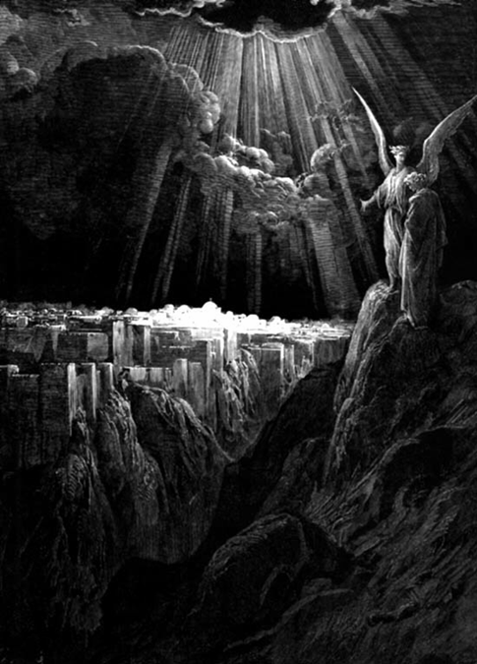
2. Who sent him into exile? Why?
3. How was St. John martyred?
a) He was beheaded.
b) He was crucified down-wards.
c) He was shot with arrows.
d) He was burned in fire.
e) He wasn't martyred.
4. How many gates does New Jerusalem have? ________
5. The walls of New Jerusalem were made of ______________, and the streets of the city were pure __________, like transparent _______________.
6. There shall be no ______________ in Heavenly Jerusalem because the glory of __________ shines in it at _________________. [God, all times, night]
7. Nothing will enter New Jerusalem that ____________
a) defiles
b) causes hate
c) brings a lie
d) causes a curse
e) all the above

 Prepared by Ossama Ekladious, St. George Coptic Orthodox Church, Bellflower, CA
❖ References Used: The Book of Revelation (Commentary), Fr. Tadros Yacoub Malaty, translated by Victoria & Ramzy Malaty, St. George Coptic Orthodox Church, Sporting- Alexandria, Egypt, 1998

