E
Name: ____________________________
First Last
Christ Is Risen
JOHN 20

I am the resurrection and the life. He who believes in Me, though he may die, he shall live.
John 11:25

1. The verse that gives a blessing to those who believe without seeing is:
a) 26 b) 24 c) 25 d) 27 e) 29

2. Our Lord comes and gives peace when the doors are closed. Which verse shows this fact?
a) 24 b) 25 c) 26 d) 27 e)28

3. Who was the disciple that was absent?
a) Peter b) John c) Jacob d) Thomas

4. How many times did the Lord Jesus say, "Peace be unto you" to his disciples?
a) 1 b) 2 c) 3 d) 4
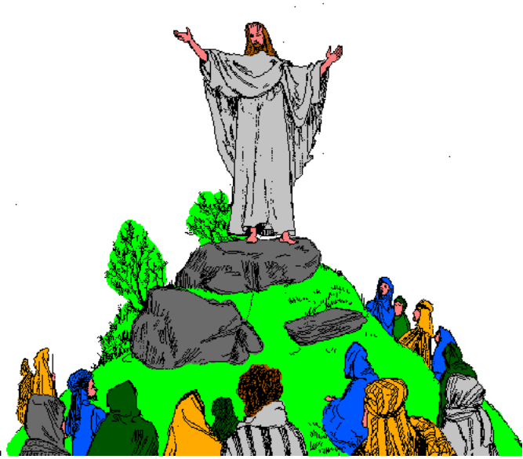

5. What did Thomas say after he touched the Lord's hands and side?

6. After _________ days, _________ appeared to His ______________ ,and ___________ was with them.

7. Which Church Sacrament fulfills verse #23?
a) Communion
b) Baptism
c) Confession
d) Unction of the Sick
U
NAME:____________________________
first last
HOLY PASCHA WEEK
Luke Chapters 19 - 23
Behold! The Lamb of God who takes away the sin of the world.
John 1:29
1. During Pascha week, we pray outside the sanctuary because
a) There is no Holy Communion
b) The priest must pray with the congregation
c) The sanctuary becomes Jesus Christ's tomb
d) Jesus Christ was crucified outside Jerusalem

2. Beginning with the eve of Pascha Wednesday, we do not greet each other because
a) We act sad
b) Judas betrayed Jesus with a kiss
c) We dislike one another
d) Jesus Christ is crucified
e) Jesus did not greet His disciples

3. Match the events that take place on the given days of Pascha Week:
Monday The salvation of the whole world
Tuesday Jesus washes the disciples' feet
Wednesday Hymns have melodies that are half sad & half festal
Thursday Jesus drives out those making business in the Temple
Friday We rejoice in our resurrection with Jesus Christ
Saturday The chief Jewish priests plot to kill Jesus Christ
Sunday Judas sells Jesus for 30 silver pieces

4. On _____________(day) of Pascha Week, Jesus Christ instituted the _________________ in the _________________ of the house of ________________. This is why we receive the _______________ on that day.

5. Before the Liturgy of Great Thursday, we pray over ____________ to commemorate the time Jesus Christ ________ the ________ of His disciples before they ate the Lord's ___________.

6. What major event takes place on Great Friday of Pascha Week?

7. What is the reason for the night vigil from Friday night until Saturday morning during Pascha Week?
U
4/4/93 NAME:____________________________ first last

The Triumphal Entry
MATTHEW 21:1-17

Hosanna to the Son of David. Blessed is He who comes in the name of the Lord. Hosanna in the highest.
Matthew 21:9

1. What does "Hosanna" mean?
a) Praise Him
b) Our King
c) Thine is the glory
d) Save us

2. God entered ___________________ riding on a ______________ to show us His h_____________.

3. On which day does the Church celebrate the Triumphal Entry?
a) Palm Sunday
b) Good Friday
c) Great Saturday
d) Easter Sunday

4. From verse #13, what do we learn to do in the House of God?
a) Day-dream
b) Pray
c) Walk around
d) Talk with friends

5. Write down a prophecy mentioned in this section:

6. Connect the symbols with what they represent:
Donkey Jesus Christ
Palm branches Gentiles
Lamb Victory
Colt Peace
Olive branches Jews
U
NAME:____________________________
first last
Holy Pentecost
Acts Chapter 2

The Spirit Himself makes intercession for us.
Romans 8:26

1. The Holy Spirit has come in the following forms, except:
a) A dove
b) Tongues of fire
c) A ghost

2. The Jews that came to Jerusalem from many nations heard the disciples speak in many languages. About how many languages did they hear?
a) 10 b) 13 c) 15 d) 20

3. What were the disciple speaking of?
a) The traditions of Jews in other countries
b) The mighty works of God
c) The meaning of Pentecost
d) The wickedness of the high priests

4. Who prophesied about the coming of the Holy Spirit?
a) Moses
b) Malachi
c) Jeremiah
d) Joel

5. How many converts were added to the Church after Peter's sermon? ________________

6. "All who _____________ were together and had all things in _______________, and ___________ their possessions and goods, and _______________ them among all, as anyone had _________________.

7. What was Peter's answer to those who eagerly sought guidance? (Write down the verse)
E
NAME:____________________________
first last

THE BIRTH OF JESUS

Matthew 1:18 - 2:12

And the Word became flesh and dwelt among us, and we beheld His glory, the glory as of the only begotten of the Father, full of grace and truth.
John 1:14

1. Which verse shows Joseph to be a just man? ______

2. The prophecy mentioned in Matt. 1:23 was said by
a) Micah b) Hosea c) Isaiah d) Jeremiah

3. What does the word "Immanuel" mean?

4. Why was Jesus Christ born in Bethlehem?
a) Because it is the city of king David
b) Bethlehem means house of bread
c) To show His humility
d) To fulfill the prophesies
e) All of the above

5. Why would king Herod be troubled about the birth of a new King?
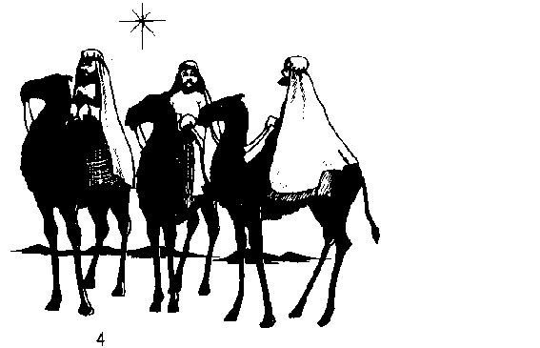

6. When did the angels appear to the Magi?
a) When they reached Jerusalem
b) After they saw Christ and worshipped Him
c) As they were following the star
d) When they told Herod about a newborn King

7. Match the following subjects with what they represent:
Magi Christ's Priesthood
Shepherds Christ's suffering
Myrrh Gentiles
Gold Jews
Frankincense Christ's Kingdom
E
NAME:___________________________
first last

THEOPHANY

Matthew 3:1-17

This is My beloved Son, in whom I am well pleased.
Matthew 3:17
1. Write the prophecy mentioned about John's mission.

2. John's baptism was a baptism of
a) Salvation b) The Holy Spirit c) Fire d) Repentance e) Christianity

3. Which verse shows that John knew the reality of his life?
a)4 b) 6 c) 11 d) 13

4. ____________ didn't need baptism because he is ____________________. He took on _____________ our _______ to clean us through _____________.
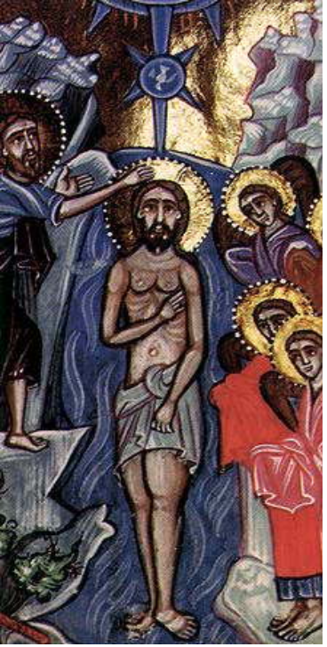

5. What should we learn from Jesus's baptism?
a) Humility
b) Holy Trinity
c) Need for baptism
d) God's love
e) All the above

6. ________________ means showing God because all three persons of the ___________________ were present at Jesus's ________________.

7. Match the persons of the Holy Trinity with their representation during Theophany:
God the Father | Dove
God the Son | Voice in heaven
God the Holy Spirit | Jesus Christ

8. What special service is done before the Liturgy on the feast of Theophany? (Name & describe)
E
NAME:____________________________
first last

Feast of the Holy Apostles
Read: Luke 10:1-20

Go into all the world and preach the gospel to every creature.
Mark 16:15
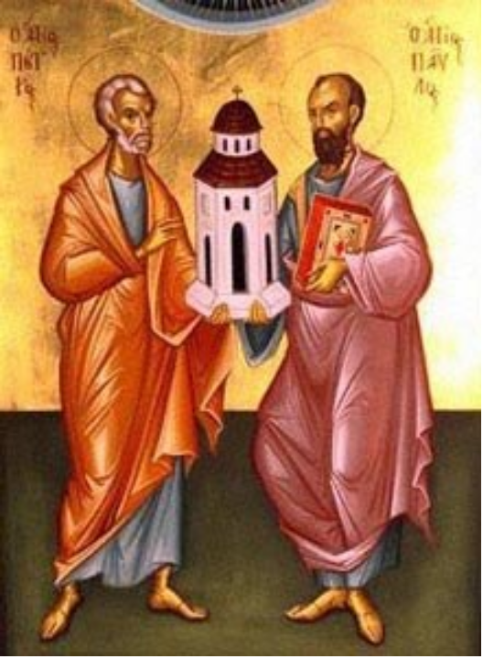
1. Which of the following actions belong to St. Peter and which belong to St. Paul: [write the Peter or Paul next to the action]

a) Denied Jesus but repented with tears [ ] b) Converted 3,000 souls with 1 sermon [ ]
c) Persecuted the Church of Jesus Christ [ ]
d) Was executed with the sword [ ]
e) Spread Christianity to the gentiles [ ]
f) Worked as a poor fisherman [ ]
g) Crucified upside down [ ]
h) Saw Jesus transfigure on mount Tabor [ ]
i) His handkerchiefs and aprons healed the sick [ ]
j) Was temporary blind until baptism [ ]

2. The Bible section you've read teaches us the importance of
a) Baptizing
b) Healing the sick
c) Visiting others
d) Evangelizing
e) Prophesying

3. We must proclaim Jesus Christ to the following groups of people:
a) Our friends
b) People not active in Church
c) People not belonging in the Church
d) People already active in Church
e) All the above

4. In order to be true evan_______[stlisge], our ____________[tiahf] and teachings must be reflected in our ___________ [toicans].

5. How was Saints Peter and Paul martyred by emperor Nero?

St. Peter was _____________________________________________.
St. Paul was ______________________________________________.
E
NAME:____________________________
first last

Jesus' Betrayal And Arrest
Luke 22:47-53

Judas, are you betraying the Son of Man with a kiss?
Luke 22:48

1. Judas betrayed Jesus: [fill in the blanks]
a) Who is his _________ | c) during the feast of ____________
b) with a symbol of _________ | d) in a place of ___________

2. We can also betray our Lord Jesus by
a) Lying b) Cheating c) Cursing d) Hating others e) All the above

3. The outward _____________ must reflect the _______________ truth when we deal with ___________; otherwise, we will be ______________ others like Judas.

4. How did our Lord Jesus repay Judas for betraying Him?

5. The Week Before Jesus Died
E
NAME:____________________________
first last

The Parable Of The Wise & Foolish Virgins
Matthew 25:1-13

Blessed are the pure in heart, for they shall see God.
Matthew 5:8

1. In this parable, who refers to the son of man?
a) the lamp
b) the oil
c) any wise virgin
d) the bridegroom
e) the wise virgins

2. In this passage, our Lord is not talking about
a) the kingdom of heaven
b) the closed door
c) the empty vessels
d) the marriage
e) the fig tree

3. Doomsday is referred to in verse
a) 4 b) 6 c) 10 d) 13 e) 15

4. Match the story's symbolism:
The wedding feast | those entering God's kingdom
The Bridegroom | works of mercy
The five wise virgins | those cast out into darkness
The five foolish virgins | purity and holiness
The oil | Jesus Christ
The lamps | the Kingdom of Heaven

5. List the 9 fruits of the Holy Spirit: [Hint in Galatians 5]
1. | 6.
2. | 7.
3. | 8.
4. | 9.
5.

E
NAME:____________________________
first last

The Parable Of The Sower
Matthew 13:1-23
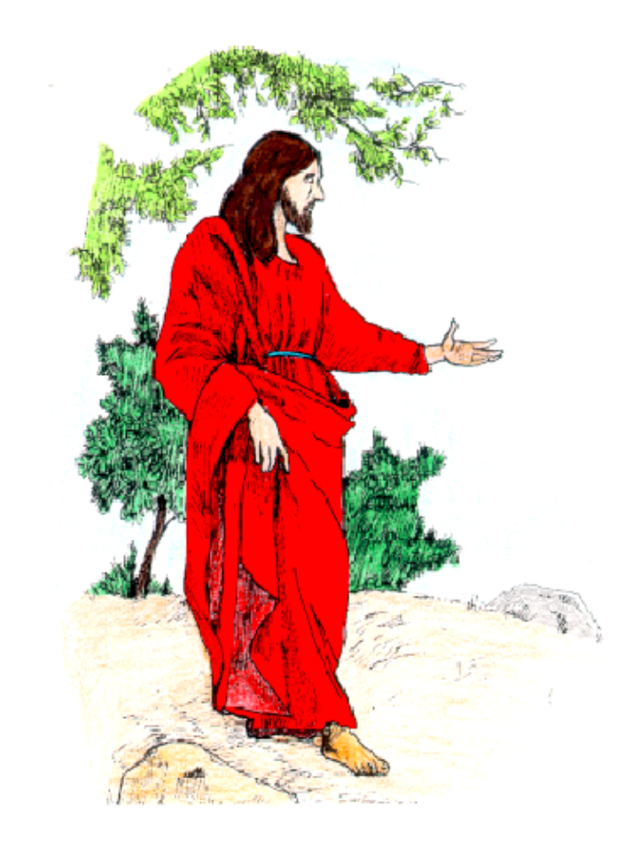
He who hears My word and believes in Him Who sent Me has everlasting life.
John 5:24
1. How many kinds of soil did the seeds fall on?
a) 2 b) 3 c) 4 d) 1

2. Which soil brought fruit?
a) The wayside
b) The rocky ground
c) The thorny ground
d) The good ground

3. To whom did the Lord explain the parable?
a) The disciples
b) The multitude
c) Peter
d) John

4. Match the following to make complete sentences:
(a) The sower is | ( ) cares and pleasures of life.
(b) The seeds are | ( ) the devils.
(c) The fowls of the air are | ( ) the words of God.
(d) The thorns are | ( ) God.

5. Use the same order of choices in question #2 to answer this question:
What kind of soil does the following people resemble?
a) After X had gone out of Church, he bought a lottery ticket. ( )
b) After Y had gone out of Church, he forgot what the lesson was about. ( )
c) After Z had gone out of Church, he started to worry about every little thing. ( )
E
NAME:____________________________
first last

The Parable Of The Rich Man & Lazarus
Read: Luke 16:19-31

1. The dialog in this parable is between
If they do not hear Moses and the prophets, neither will they be persuaded though one rise from the dead.
Luke 16:31
a) The rich man and Lazarus | c) The rich man and Abraham
b) Abraham and Moses | d) Abraham and Lazarus

2. The dogs were more merciful to Lazarus than
a) the angels b) Abraham c) his brothers d) the rich man

3. Whose fate was sad?
a) The rich man's brothers | c) The rich man
b) Lazarus | d) Moses

4. Why did our Lord tell us this parable?
a) to pass the great gulf | c) to show us what Lazarus suffered
b) to enjoy life while we are on earth | d) to repent and be merciful

5. Use the clues to unscramble the words. Then write the circled letters in order in the spaces at the bottom of the page to find the rich man's request.
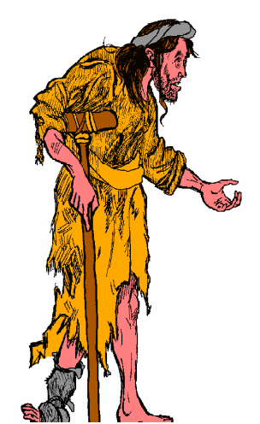
(v.24) the rich man called to ___ ___ ___ ___™___ ___ [MAAHBAR]
(v.20) a beggar named ___ ___ ___ ™___ ___ ___ [ZARALUS]
(v.28) number of rich man's brothers: ___ ___ ™™ [IFEV]
(v.19) rich man dressed in ™___ ___ ___ ___ ___ [ELURPP]
(v.31) ___ ™___ ™___ ___ [TINSEL] to Moses and the Prophets
(v.19) rich man lived in ___ ___ ___ ___ ___ ™ [RXULUY]
(v.20) covered with ___ ™___ ___ ___ [ROESS]
(v.31) they will not be ___ ___ ___ ___ ___ ™___ ___ ___ [CDCNNVIOE]
(v.28) this place of ___ ___ ___ ™™___ ___ [TTREMON]

___ ___ ___ ___ ___ ___ ___ ___ ___ ___ ___ ___
E
NAME:____________________________
first last

Feeding The Multitude
Read: John 6:1-14

The blessing of the Lord makes one rich, and He adds no sorrow with it.
Proverbs 10:22

1. The people sat down in groups of _______
a) 5 b) 50 c) 5000 d) 2

2. What should we learn from this miracle?
a) To sit in groups
b) To have enough food when we go out
c) To pray before we eat
d) To eat enough fish & bread

3. The twelve disciples picked up ______ baskets of leftover food after everyone ate.
a) 2 b) 5 c) 12 d) 50

4. Jesus Christ said, "____________ the fragments that remain, so that nothing is _________."

5. Jesus Christ was testing the faith of
a) Philip b) John c) Peter d) The people

6. This miracle shows that Jesus Christ has power to create ____________.

7. What should we learn from the boy who gave away his lunch?
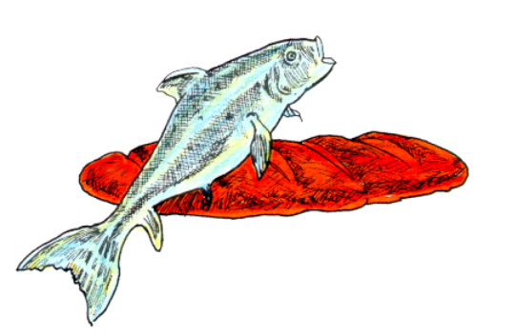
E
NAME:____________________________
first last

A Man Born Blind Receives Sight
Read: John 9:1-41

Memory Verse:
I am the light of the world
John 9:5

1. Our Lord Jesus is God, the Creator. Which verse shows this fact? _____

a) 6 b)17 c) 29 d) 38
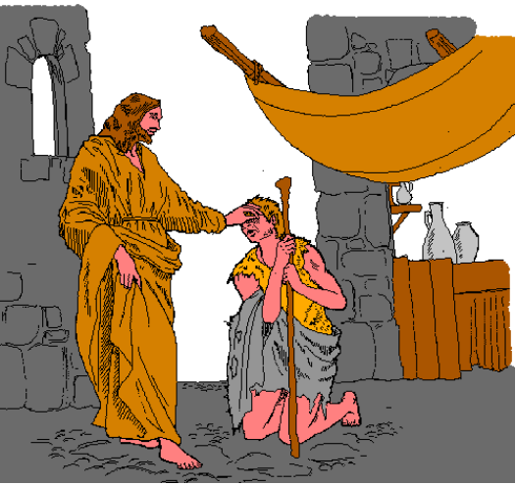

2. A great change of condition is shown in verse ____

a) 4 b) 16 c) 23 d) 25 e) 38

3. The prophet mentioned in this section is ____________

a) David b) Moses c) Joshua d) Abraham

4. Our Lord was accused of

a) being a deceiver
b) not keeping the Sabbath
c) not being from God
d) being a sinner
e) all the above

5. ____________ created eyes from ____________ like He created ___________ from dust.

6. Who hardened his heart and thus became blind? _________________

7. To which group of people does God give the sight of faith? [mark all possible answers]

a) the simple
b) the proud
c) the humble
d) those seeking the praise of men
E
NAME:____________________________
first last

Jesus Calms The Storm
Read: Matthew 8:23-27

Memory Verse:
Why are you fearful, O you of little faith.
Matthew 8:26
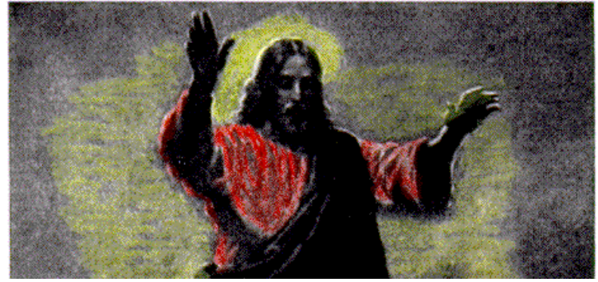

1. What happened during the trip? ____

a) The disciples started fishing.
b) A strong storm came up.
c) Some disciples slept.
d) Jesus walked on water.
e) All the above

2. Which verse shows the power of our Lord Jesus Christ over nature? ____

a) 20 b) 23 c) 25 d) 26

3. Why did our Lord blame his disciples? ____

a) He wanted to sleep longer.
b) They were sailing slowly.
c) They didn't prepare for the storm.
d) They had a little faith.
e) They depended on Him.

4. The ______________ in this story represents the tribulations that happen in our lives.

5. Who is able to calm the storms in our lives? _________________

6. _________________ said a word and the _________ and sea obeyed; this proves His ___________ [IVIYTNID].

7. What should we do when we get in difficulty?

E
NAME:____________________________
first last

Jesus Heals A Paralytic
Read: Mark 2:1-12

Memory Verse:
When Jesus saw their faith, He said to the paralytic, "Son, your sins are forgiven you."
Mark 2:5
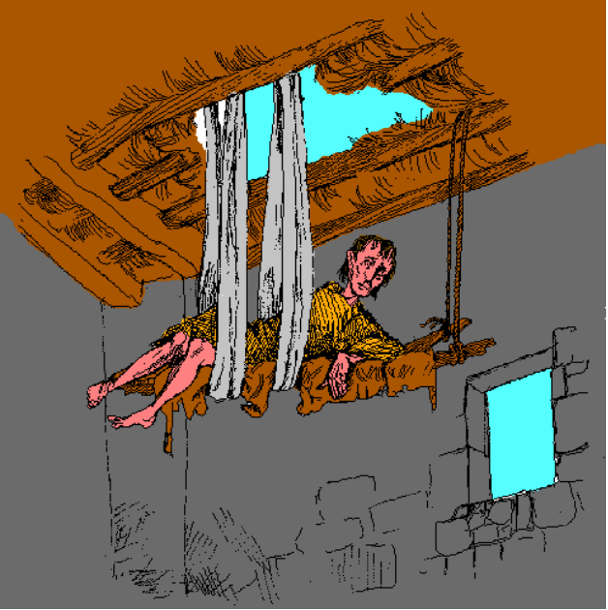
1. Where did Jesus heal the paralytic? _______

a) Bethlehem
b) Capernaum
c) Jerusalem
d) Cana of Galilee

2. Why did the crowd gather around the house? _______

a) to hear Jesus
b) to see a miracle
c) to pray
d) to eat dinner
e) to celebrate

3. Who carried the bed? _______

a) the crowd b) Jesus c) the sick man d) the 4 friends e) c & d

4. The man was healed because of his friends' faith; this is an example of _________________ [NTERNICOSISE].

5. What was the source of the man's sickness? ___________________

6. The _______________ accused Jesus of _____________ing[LSBAHPME] because He ______________ the sins of the _____________________.

7. What is required for miracles to happen in our lives?

E
NAME:____________________________
first last

The Transfiguration
Read: Mark 9:2-13

Memory Verse:
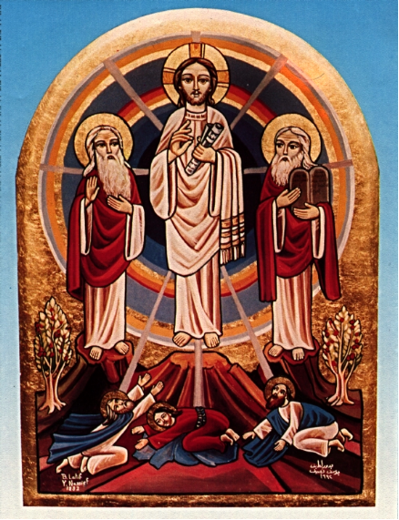
This is My beloved Son. Hear Him!
Mark 9:7

1. Whom did our Lord take to the mountain? _______
a) Peter & John
b) John & James
c) Peter, John, and James
d) Mark, Luke, & John
e) Paul, Peter, & John

2. These appeared in glory with our Lord Jesus on the mountain:
a) Moses b) Isaiah c) Elijah d) Jeremiah e) David f) a & c

3. Our Lord Jesus is the Son of God; this is shown in verse _______
a) 3 b) 7 c) 8 d) 9 e) 13

4. Peter was so pleased with the heavenly scene. Which verse proves this?
a) 3 b) 5 c) 6 d) 12

5. ____________________ means a change in appearance.

6. A ___________ came out of the ____________, saying, "This is My _____________ Son. ___________ Him!"

7. What does the transfiguration prove?
E
NAME:____________________________
first last

The Miraculous Great Netting Of Fish
Read: Luke 5:1-11

Memory Verse:
Master, we have toiled all night and caught nothing; nevertheless at Your word I will let down the net.
Luke 5:5
1. Which lake is mentioned in this section? _______
a) Gennesaret b) Bethesda c) Siloam d) Jordan e) All the above

2. Whose boat did our Lord teach the people from? ______
a) James' b) John's c) Peter's d) Andrew's

3. The disciples caught a large number of fish because _______
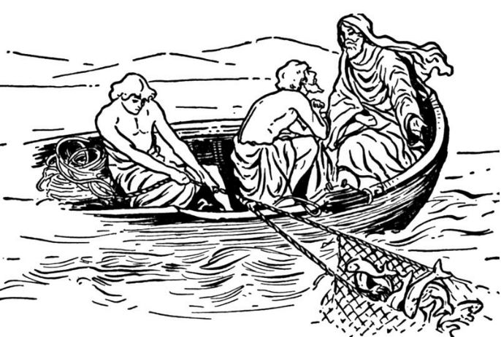
a) they believed in the Lord's word.
b) it was the right time to catch fish.
c) it was the right place to catch fish.
d) they were very skilled fishermen.
e) they put on some light at night.

4. How was Peter promoted? ______
a) He will catch fish in a greater lake.
b) He will be the head of the fishermen.
c) He will catch men.
d) He will sell fish for a large sum of money.

5. What did the disciples do after they pulled the two boats to the shore? _______
a) They started to sort the fish.
b) The left everything and followed our Lord.
c) They started to sell the fish.
d) The started to eat the fish.
e) They started to wash their nets.

6. ______________ fell down at _____________ knees, saying, "______________ from me, for I am a ____________ man, O Lord!"

7. What should be done when a great blessing happens in our lives?

